Whirly Go Round 1500 (Wheelchair Accessible)
Product Code: SPN0345FBA | Required Space | Max. Equipment Height: 840mm
Age Range: Inclusive Play | Diam: 5.7m Area: 25.5m2 | Critical Fall Height: 600mm
Capacity: Recommended up to 5 users

Easy access for children of all abilities to play together. This Whirly Go Round sits level with the ground to accommodate wheelchairs. The sculptural stainless steel handrail adds an artistic element and extra security.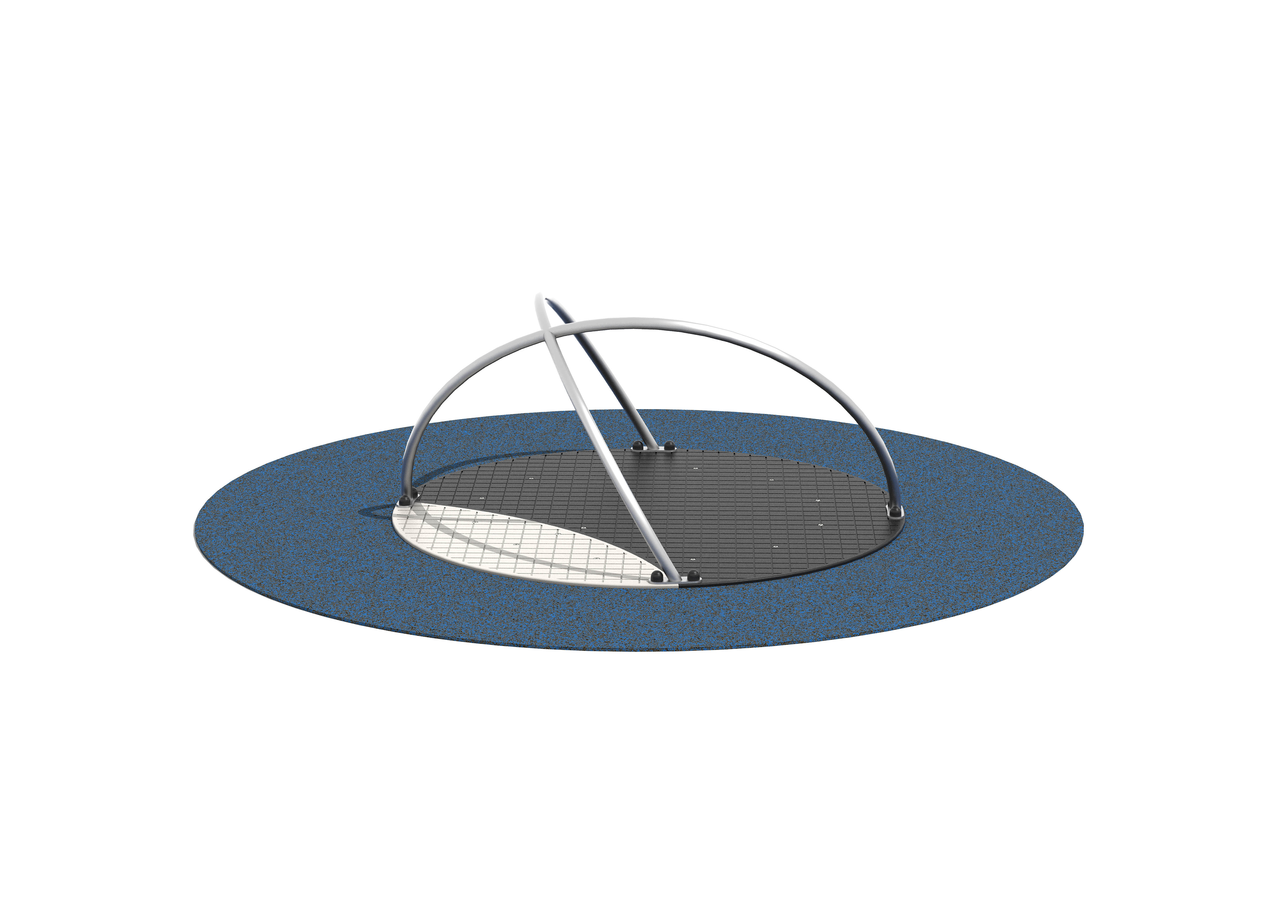
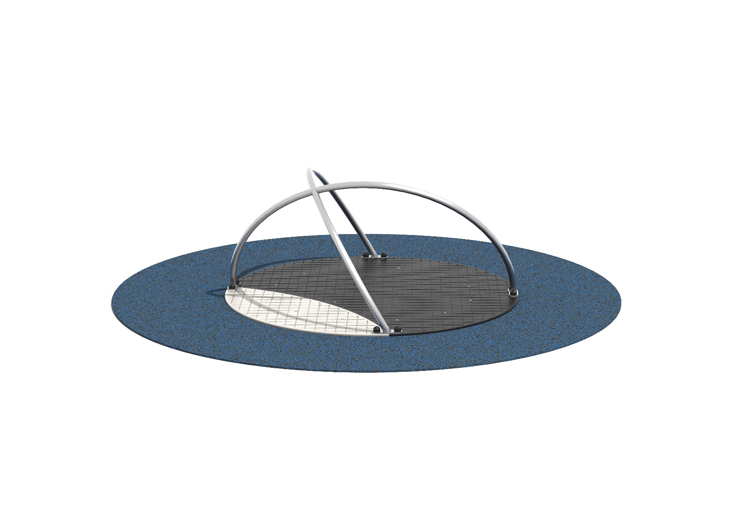
Rubber surround not included

