Whirly Go Round 1500
Product Code: SPN0240FBA | Required Space | Max. Equipment Height: 840mm
Age Range: Inclusive Play | Diam: 5.7m Area: 25.5m2 | Critical Fall Height: 600mm
Capacity: Recommended up to 5 users

Spin at speed to create an adrenalin rush! Feel the G-forces while gripping the sculptural stainless steel handrail. Guaranteed fun for children of all ages to play together
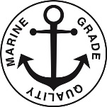
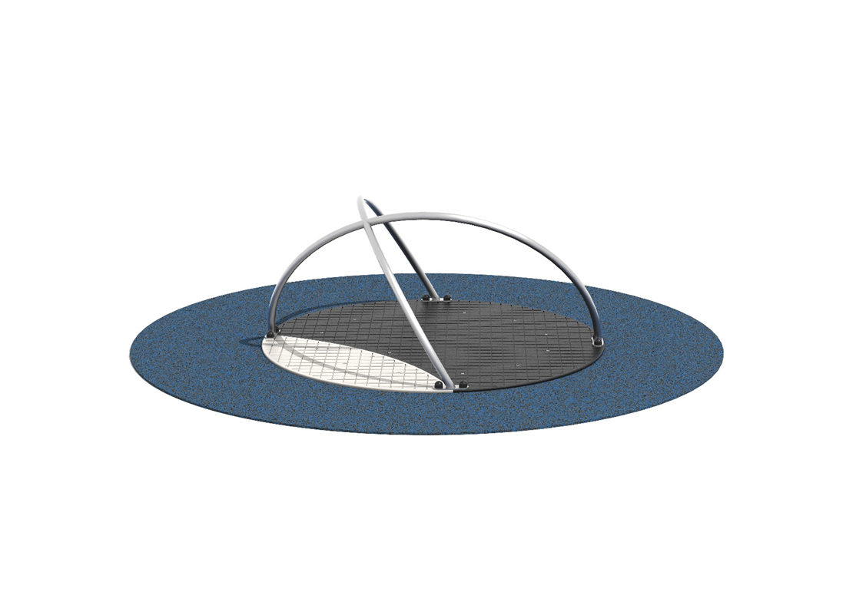
Spin at speed to create an adrenalin rush! Feel the G-forces while gripping the sculptural stainless steel handrail. Guaranteed fun for children of all ages to play together
Surface level and below ground level options available

